Contents

[**Project Overview** 2](#_Toc172495845)

[**Steps Involved** 2](#_Toc172495846)

[**Technical Expertise Required** 2](#_Toc172495847)

[**High-Level Architecture** 2](#_Toc172495848)

[**Technologies and Tools Required** 3](#_Toc172495849)

[Detailed Technical Requirements 4](#_Toc172495850)

[Detailed Steps and Implementation for "Meta-Human Interviewer" 5](#_Toc172495851)

[**Possible Challenges for the AI-Based Meta-Human Interview Project** 7](#_Toc172495852)

[1. Accurate Speech Recognition and Synthesis 8](#_Toc172495853)

[2. Realistic Meta-Human Animation 8](#_Toc172495854)

[3. Effective AI-Based Evaluation 8](#_Toc172495855)

[4. Seamless Integration with Existing Systems 8](#_Toc172495856)

[**Existing AI Interview Products** 8](#_Toc172495857)

[**Conclusion** 9](#_Toc172495858)

**Project Overview**

The project aims to develop an AI-based meta-human bot that conducts candidate interviews, interacting with candidates in English. The bot will analyse verbal responses and facial expressions to evaluate candidates and generate detailed performance reports.

**Steps Involved**

1. **Resume Upload and Sorting**: Candidates upload their resumes to a designed portal, which sorts them based on their profile and job description. Candidates then select an interview date and time.
2. **Interview Scheduling**: The system confirms the selected interview date and time.
3. **Meta-Human Interview**: At the scheduled time, the AI meta-human bot conducts the interview via a communication channel (e.g., Microsoft Teams, Zoom or self-owned).
4. **Interaction and Analysis**: The bot interacts with candidates, listens to their responses, and observes facial expressions to provide real-time feedback and ensure comfort.
5. **Performance Evaluation**: After the interview, the bot consolidates answers and evaluates the candidate's performance based on their responses, confidence, and communication skills, generating a detailed report.

**Technical Expertise Required**

1. **Machine Learning and AI**:
   * Natural Language Processing (NLP) for understanding and generating responses.
   * Computer Vision for facial expression analysis.
2. **3D Animation and Graphics**:
   * Creating a realistic meta-human avatar.
3. **Speech Recognition and Synthesis**:
   * Recognizing and generating natural speech.
4. **Data Engineering**:
   * Managing resume uploads, scheduling, and interview data.
5. **Backend Development**:
   * Building the infrastructure for the portal and scheduling system.
6. **Frontend Development**:
   * Creating a user-friendly portal for resume uploads and interview scheduling.
7. **Integration**:
   * Integrating with communication tools like Microsoft Teams/Zoom/Custom.
8. **DevOps**:
   * Deploying and maintaining the system.

**High-Level Architecture**

1. **Frontend**:
   * **User Portal**: For resume upload and interview scheduling.
   * **Interview Interface**: For candidates to interact with the meta-human bot.
2. **Backend**:
   * **API Layer**: Managing interactions between the frontend, database, and AI models.
   * **Database**: Storing resumes, interview schedules, responses, and performance reports.
   * **Scheduler**: Handling interview scheduling and reminders.
3. **AI Components**:
   * **NLP Model**: For understanding and generating candidate responses.
   * **Speech Recognition and Synthesis Model**: For converting speech to text and vice versa.
   * **Facial Expression Analysis Model**: For evaluating facial expressions during the interview.
   * **Evaluation Model**: For judging performance based on responses and expressions.
4. **Meta-Human Avatar**:
   * **3D Animation Engine**: For creating and animating the meta-human bot.
   * **Speech and Gesture Synchronization**: Ensuring the meta-human’s speech and gestures are natural and synchronized.
5. **Integration**:
   * **Communication Tools**: Integration with Microsoft Teams or other platforms for conducting interviews.

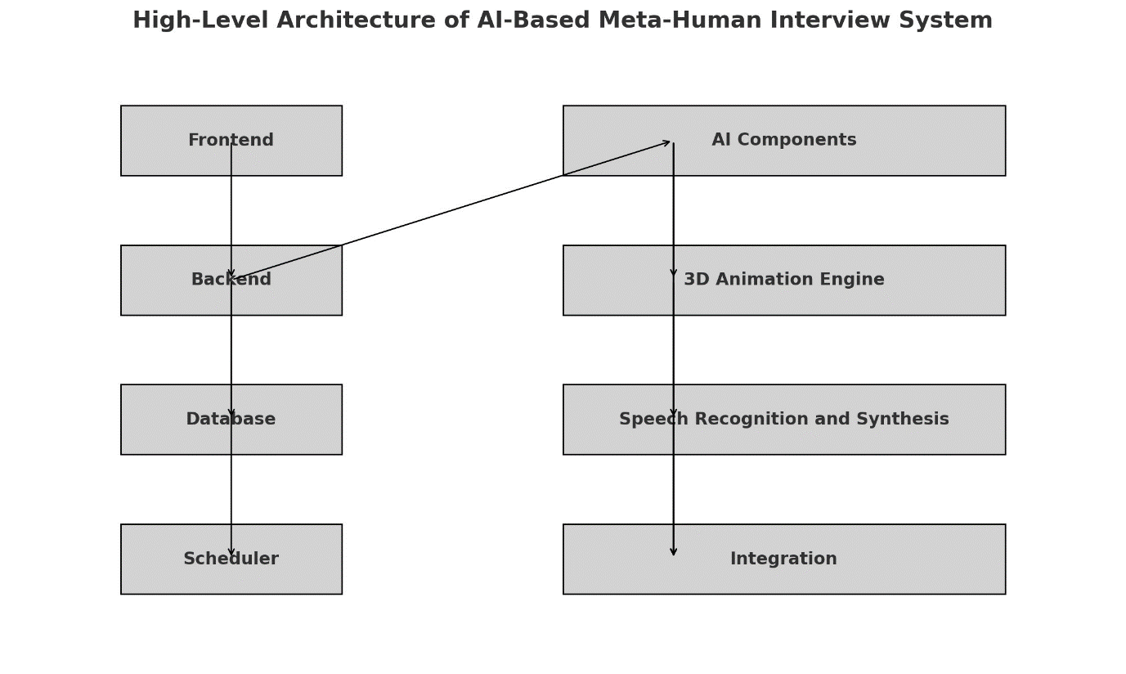

**Technologies and Tools Required**

1. **Programming Languages**:
   * Python: For AI models and backend development.
   * JavaScript (React.js, Node.js): For frontend development.
   * C++/C#: For 3D animation engine and real-time interaction.
2. **Frameworks and Libraries**:
   * **NLP**: Hugging Face Transformers, NLTK, spaCy.
   * **Speech Recognition and Synthesis**: Google Speech-to-Text, Amazon Polly.
   * **Facial Expression Analysis**: OpenCV, Dlib, TensorFlow, Keras.
   * **3D Animation**: Unreal Engine, Unity, MetaHuman Creator.
   * **Backend**: Flask, Django, or FastAPI.
   * **Frontend**: React.js or Angular.
3. **Database**:
   * PostgreSQL, MongoDB, or MySQL.
4. **DevOps**:
   * Docker, Kubernetes for containerization and orchestration.
   * CI/CD tools like Jenkins or GitHub Actions.
5. **Cloud Services**:
   * AWS, Google Cloud, or Azure for hosting and scalability.
   * AWS SageMaker or Google AI Platform for model training and deployment.
6. **Communication Tools**:
   * Microsoft Teams API or Zoom API or Self Developed tool for conducting interviews.
7. **Other Tools**:
   * Git for version control.
   * JIRA or Trello for project management.

### Detailed Technical Requirements

#### 1. Resume Upload and Sorting

**Requirements:** User-friendly portal, API, database storage, AI model for matching resumes to job descriptions. **Technologies:** React.js/Angular, Flask/Django/FastAPI, PostgreSQL/MongoDB, Scikit-Learn/TensorFlow. **Roles:** Frontend Developer, Backend Developer, Data Scientist, Database Administrator.

#### 2. Interview Scheduling

**Requirements:** Calendar interface, scheduling API, database storage. **Technologies:** React.js/Angular, Flask/Django/FastAPI, PostgreSQL/MongoDB, Celery/APScheduler. **Roles:** Frontend Developer, Backend Developer, Database Administrator.

#### 3. Meta-Human Interview

**Requirements:** 3D avatar animation, speech-to-text, text-to-speech, NLP, integration with communication platforms. **Technologies:** Unreal Engine/Unity, Google Speech-to-Text, Google Text-to-Speech, Hugging Face Transformers, Microsoft Teams API. **Roles:** 3D Animator, Speech Recognition Engineer, Speech Synthesis Engineer, NLP Engineer, Integration Developer.

#### 4. Interaction and Analysis

**Requirements:** Real-time interaction, facial expression analysis, data storage. **Technologies:** WebRTC/Socket.io, OpenCV/Dlib, PostgreSQL/MongoDB. **Roles:** Real-time Interaction Developer, Computer Vision Engineer, Database Administrator.

#### 5. Performance Evaluation

**Requirements:** Analyze verbal responses and expressions, generate reports. **Technologies:** Hugging Face Transformers, OpenCV/Dlib, Jupyter Notebooks/Pandas. **Roles:** NLP Engineer, Computer Vision Engineer, Data Scientist.

### Detailed Steps and Implementation for "Meta-Human Interviewer"

#### Overview

The "Meta-Human Interview" phase involves creating an AI-driven, lifelike avatar capable of conducting real-time, interactive interviews with candidates. This process combines 3D animation, speech recognition, speech synthesis, and natural language processing (NLP) to create a seamless and realistic interview experience.

#### Steps and Implementation

1. **Creating the Meta-Human Avatar**

**Goal**: Develop a realistic 3D avatar that can interact naturally with candidates.

**Technologies**:

* + **3D Animation Engines**: Unreal Engine, Unity.
  + **MetaHuman Creator**: For creating high-fidelity digital humans.

**Implementation**:

* + **Design and Animation**: Use MetaHuman Creator to design the avatar's physical appearance, including facial features, expressions, and body movements.
  + **Integration**: Import the designed avatar into Unreal Engine or Unity for further animation and integration.
  + **Gesture and Movement**: Animate gestures and body movements to match the speech and interaction context using the animation engine's tools.

1. **Speech Recognition and Synthesis**

**Goal**: Enable the avatar to understand spoken language and respond naturally.

**Technologies**:

* + **Speech Recognition**: Google Speech-to-Text, Amazon Transcribe.
  + **Speech Synthesis**: Google Text-to-Speech, Amazon Polly.
  + **Voice and Lip Syncing**: Tools like Faceware or Replica Studio for syncing the avatar’s lip movements with speech.

**Implementation**:

* + **Speech-to-Text**: Integrate a speech recognition API to transcribe the candidate’s spoken responses into text.
  + **Text-to-Speech**: Use a text-to-speech API to generate natural-sounding speech for the avatar’s responses.
  + **Lip Syncing**: Ensure the avatar’s lip movements are synchronized with the synthesized speech using animation tools.

1. **Natural Language Processing (NLP)**

**Goal**: Enable the avatar to understand, process, and generate human-like responses.

**Technologies**:

* + **NLP Libraries**: Hugging Face Transformers, spaCy.
  + **Dialogue Management**: Rasa, Microsoft Bot Framework.
  + **Contextual Understanding**: BERT, GPT models for contextual understanding and response generation.

**Implementation**:

* + **Response Understanding**: Use NLP models to parse and understand the candidate’s responses.
  + **Dialogue Flow**: Implement a dialogue management system to handle the flow of conversation based on candidate responses.
  + **Response Generation**: Use pre-trained models like GPT-3 to generate natural and contextually appropriate responses.

1. **Integration with Communication Platforms**

**Goal**: Seamlessly integrate the avatar with communication platforms like Microsoft Teams for conducting interviews.

**Technologies**:

* + **APIs**: Microsoft Teams API, Zoom API.
  + **Real-time Communication**: WebRTC, Socket.io.

**Implementation**:

* + **API Integration**: Use the communication platform’s API to schedule and manage interview sessions.
  + **Real-time Interaction**: Implement real-time video and audio communication capabilities using WebRTC.
  + **Session Management**: Ensure the avatar joins the interview session on time and manages the interaction flow smoothly.

**Possible Challenges for the AI-Based Meta-Human Interview Project**

### 1. Accurate Speech Recognition and Synthesis

**Problem:** Difficulty in recognizing and synthesizing diverse speech patterns and accents.

**Solution:** Use advanced speech models like Google Speech-to-Text and fine-tune them for different accents.

### 2. Realistic Meta-Human Animation

**Problem:** Creating lifelike and responsive avatars.

**Solution:** Utilize high-quality 3D models and motion capture technology with engines like Unreal Engine.

### 3. Effective AI-Based Evaluation

**Problem:** Accurately assessing candidate performance.

**Solution:** Implement multi-modal analysis combining NLP, facial recognition, and voice analysis.

### 4. Seamless Integration with Existing Systems

**Problem:** Integrating with existing HR tools and communication platforms.

**Solution:** Use RESTful APIs and modular architecture for easy integration and compatibility.

**Existing AI Interview Products**

Several AI-powered interview tools already exist in the market, though their capabilities and approaches vary. Here are a few notable examples:

1. **GreetAI**:
   * **Functionality**: Conducts mock interviews, provides instant feedback on answers and expressions, and offers video recordings and transcriptions for review.
   * **Focus**: Mainly designed for practice, helping candidates improve their interview skills by analyzing their responses and facial expressions​ ([Greetai](https://www.greetai.co/practice" \t "_blank))​.
2. **Interview Copilot**:
   * **Functionality**: Provides real-time interview assistance, including recording and feedback features.
   * **Focus**: Supports candidates through the interview process, offering guidance and feedback to help them perform better​ ([Interview Copilot](https://interviewcopilot.io/#:~:text=URL%3A%20https%3A%2F%2Finterviewcopilot.io%2F%0A,100))​.
3. **InterviewBot**:
   * **Functionality**: Allows users to pick avatars, set preparation times, and conduct simulated interviews.
   * **Focus**: Emulates the interview experience with AI avatars, providing a platform for candidates to practice and improve their skills​ ([InterviewBot](https://interviewbot.com/" \l ":~:text=URL%3A%20https%3A%2F%2Finterviewbot.com%2F%0AVisible%3A%200%25%20" \t "_blank))​.
4. **MyInterview**:
   * **Functionality**: Uses AI to assess candidate responses and personality traits. It provides hiring managers with transcripts and personality assessments.
   * **Focus**: Assists hiring managers by evaluating candidates based on their video responses, aiming to reduce human bias in the hiring process​ ([MIT Technology Review](https://www.technologyreview.com/2021/07/07/1027916/we-tested-ai-interview-tools/))​.

**Conclusion**

While there are several AI interview tools available, our project stands out due to its use of a realistic meta-human avatar, comprehensive real-time analysis, and detailed reporting capabilities. These features can offer a more immersive and thorough candidate evaluation process, potentially making our solution more effective and appealing in the market.